Advanced Database Training
2026
Vaishnavi Kamthe

Assignment 2a
1. Write a query to display the actor’s name (first and last name), gender and the count of movies in which he/she has enacted.
SELECT a.act_fname, a.act_lname, a.act_gender,
COUNT(mc.mov_id) AS movie_count
FROM actor a
JOIN movie_cast mc ON a.act_id = mc.act_id
GROUP BY a.act_id, a.act_fname, a.act_lname, a.act_gender;
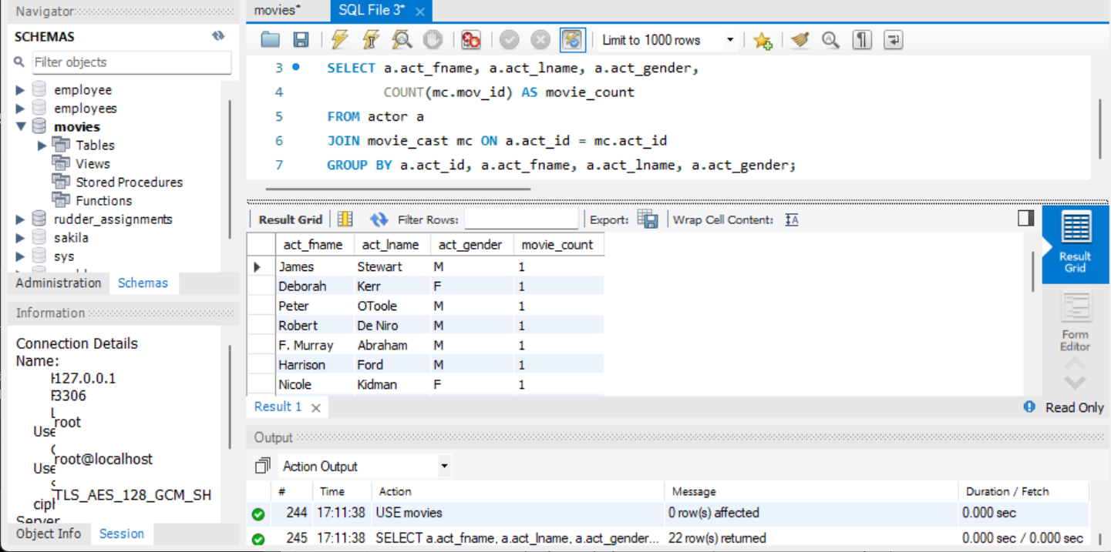
2. Write a query to display movie details (mov_id, mov_title, mov_year) and rank the movies based on their review stars, keeping the null records at the end.
SELECT m.mov_id, m.mov_title, m.mov_year,
RANK() OVER (ORDER BY r.rev_stars DESC) AS movie_rank
FROM movie m
LEFT JOIN rating r ON m.mov_id = r.mov_id
ORDER BY (r.rev_stars IS NULL), r.rev_stars DESC;
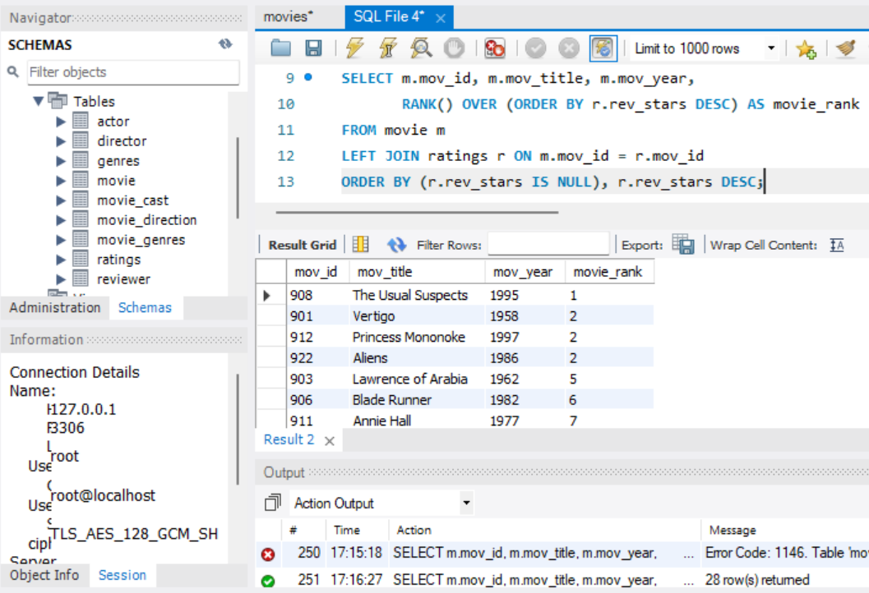
3. Write a query to find the name of the director (first and last names) who directed a movie that casted a role for ‘Alvy Singer’.
SELECT DISTINCT d.dir_fname, d.dir_lname
FROM director d
JOIN movie_direction md ON d.dir_id = md.dir_id
JOIN movie_cast mc ON md.mov_id = mc.mov_id
WHERE mc.role = 'Alvy Singer';
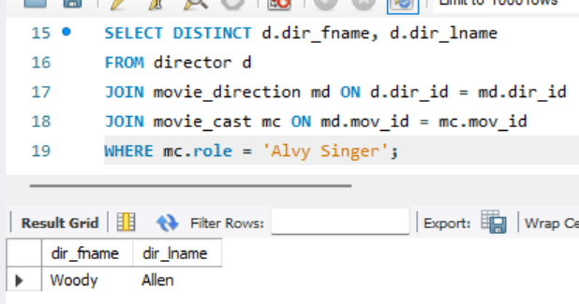
4. Print all the columns from the movies table of the movie that has the second highest Number of ratings.
SELECT * FROM movie
WHERE mov_id = (
SELECT mov_id
FROM rating
GROUP BY mov_id
ORDER BY COUNT(*) DESC
LIMIT 1 OFFSET 1
);
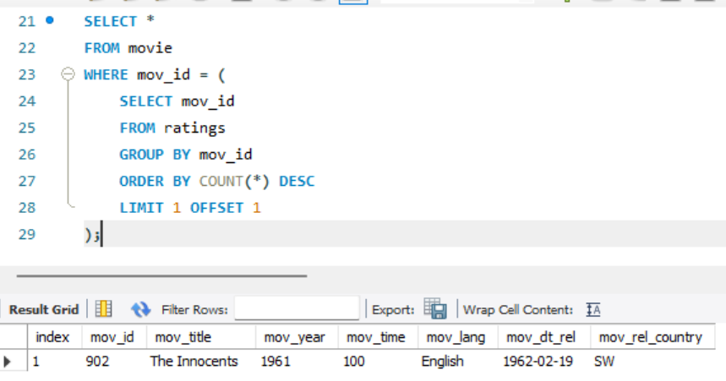
5. Write a query to find the actor id, first and last name of all the actors that have appeared in the movie which was also directed by them.
SELECT DISTINCT a.act_id, a.act_fname, a.act_lname
FROM actor a
JOIN movie_cast mc ON a.act_id = mc.act_id
JOIN movie_direction md ON mc.mov_id = md.mov_id
WHERE a.act_id = md.dir_id;
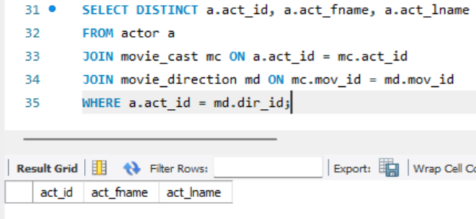
6. Write a query to compute a report which contains the genres of those movies with their average time and number of movies for each genre.
SELECT g.gen_title,
AVG(m.mov_time) AS avg_time,
COUNT(*) AS movie_count
FROM movie m
JOIN movie_genres mg ON m.mov_id = mg.mov_id
JOIN genres g ON mg.gen_id = g.gen_id
GROUP BY g.gen_title;
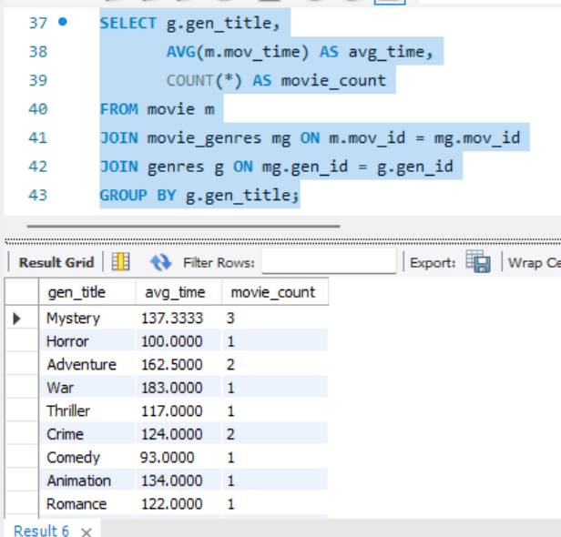
7. Write a query in SQL to find the movie title, actor first and last name, and the role for those movies where one or more actors acted in two or more movies.
SELECT m.mov_title, a.act_fname, a.act_lname, mc.role
FROM movie m
JOIN movie_cast mc ON m.mov_id = mc.mov_id
JOIN actor a ON mc.act_id = a.act_id
WHERE mc.act_id IN (
SELECT act_id
FROM movie_cast
GROUP BY act_id
HAVING COUNT(DISTINCT mov_id) >= 2
);
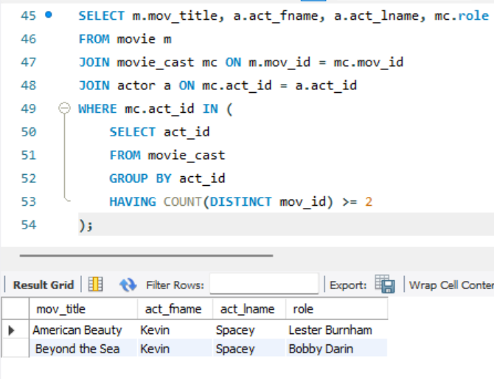
8. Write a query to clone a new table from the Movie table with all the rows. Name the table as ‘Movie_clone’.
CREATE TABLE Movie_clone AS
SELECT * FROM movie;
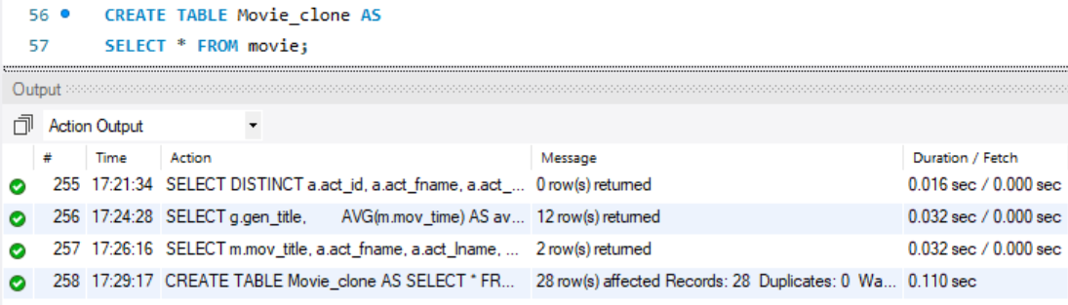
9. Update the movie release date (mov_dt_rel) to ‘yyyy-mm-dd’ format from Movie_clone table where the release date is null. The month and date should be set to 1st January and year = mov_year.
UPDATE Movie_clone
SET mov_dt_rel = STR_TO_DATE(CONCAT(mov_year, '-01-01'), '%Y-%m-%d')
WHERE mov_dt_rel IS NULL;
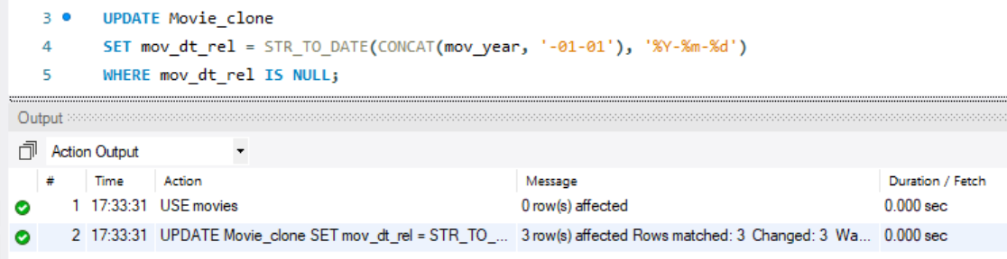
10. From the movie dataset please go through all the 9 tables and check on which table we can implement the index to increase the search performance. On that table create an index to the appropriate column. Write sql query for creating the index.
CREATE INDEX idx_movie_cast_act_id
ON movie_cast(act_id);
